Curriculum Vitae
Fredrick Henry Waite

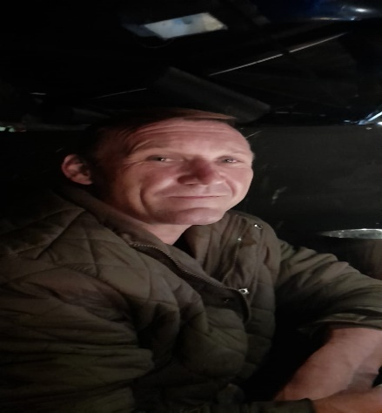

PERSONAL DETAILS
Name & Surname: Freddrick Henry Waite.
Contact no: 066 221 2539
Email: Freddywaite3@gmail.com
Languages: |  | Afrikaans & English (Speak, Read & Write)
Health: |  | Good
Address: |  | 74b 8th street Boksburg north
Marital Status: |  | Married
Dependants: |  | None
Drivers Licence: |  | C1 Code 10 / own transport
Citizenship: |  | South African
Date of Birth:  ID Number:  EDUCATIONAL HISTORY  Nobelis High School – Welkom |  | 1977-05-27  7705275016084
Year completed schooling: |  | 1994
Subjects: |  | Afrikaans
 |  | English
 |  | History
 |  | Geography
 |  | Auto Mechanic
 |  | Science

TRAINING COURSE COMPLETED
Supervisory Development Programme (Level 4)
Fire Fighting Modules 1 & 2
Emergency Preparedness
Labour Relations
Time Management Workshops
Service Excellence Workshop
Assertiveness Skills Workshop
Occuwell Health Care
Incident & Accident Investigation
First Aid
Microsoft Excel 2003
EMPLOYMENT HISTORY

Platron
(Contractor to RTL) Jan 2001 – July 2003
Position Held: Operator
Duties: Receiving and Dispatching
Allocating of stock, receiving on PC system,
Scan items onto scanner system for dispatch.
Reason for leaving: Contract expired

Capacity
(Contractor to RTL) Aug 2003 – Jan 2004
Position Held: Operator
Duties: Receiving and Dispatching
Allocating of stock, receiving on PC system,
Scan items onto scanner system for dispatch

Reason for leaving: Was offered a permanent position at RTL
Feb 2004 – Dec 2005

RTL
Position Held: Operator
Duties: Receiving and Dispatching
Allocating of stock, receiving on PC system,
Scan items onto scanner system for dispatch

Jan 2006 was promoted to Supervisor

Jan 2006 – July 2007
Position Held: Supervisor
Duties: Management of staff and stock, receiving dispatching, Daily updates of store delivery
notes and proof of receipts & general
Supervisors’ duties.

Reason for leaving: Company relocated
Reference: Eddie Topper 083 664 5456

HENTIG COATINGS August 2007- 2015

Position held: Working foreman

Duties: Supervision Panel Beating & spray shop staff
Training staff to match paints, assisting with sand blasting, priming, ensuring all painting of vehicles are done as per specks.
(Did my operatorship at Alden panel beaters)
Reason for leaving: Business Closed down
Reference: Belinda Van Den Berg 074 626 0000

Clover SA May 2015- May 2023

Position held: Senior Merchandiser - May 2023

Duties: Supervision of Receiving and order Despatch
Assisted with monthly stock take, assisted RMA on occasions (Reconciled invoices against payment and stock)

Reference: Bianca Olivier 063 414 7772

Clover SA May 2015- May 2023

Position held: Truck assistant due to closer of branch

Duties: Offloading Stock and Uplifting of returns.
Matching stock to delivery notes and invoices, counting of stock off loaded and returned.
Stock monthly stock take and checking orders

Reason for leaving: Other opportunity

Reference: Hendrik Wagner – 082 577 2697
(Stock lost controller)

Classic cars Rescuers-Jet Park

Position Held: Panel beating, stripping, preparing
Assist other staff with spray-painting.

Reason for leaving: May 2023- July 2024

Reference: Gerald Burrell- 082 653 5567(CEO)
Garage 72 - Randburg Panel beating, stripping, assembling preparing for spray-painting booth.

Reason for leaving: Temp position and Petrol costs.

Reference: Tyrone- 084 805 0634

